To Do List:

Implement mortgage into the turn

Make it so that the get out of jail free card can be reshuffled into the deck after use.

Bug Hunting

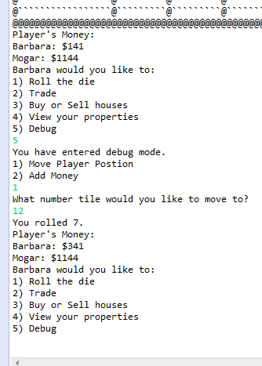

Even when you escape by rolling doubles, it repeats the jail dialogue until you pay the money